MILITARY SECURITY AND DEFENSE UNIVERSITY OF THE REPUBLIC OF UZBEKISTAN
INFORMATION AND COMMUNICATION TECHNOLOGIES AND MILITARY COMMUNICATIONS INSTITUTE
DEPARTMENT OF CYBERSECURITY
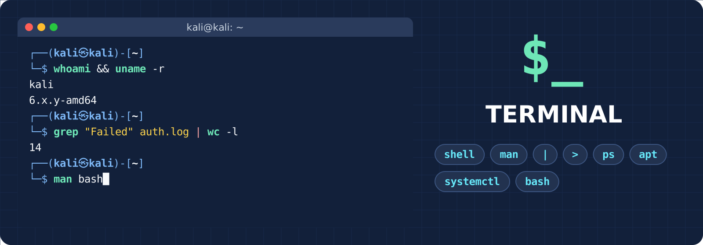
STUDY GUIDE AND PRACTICAL WORKBOOK
“Cyber Forensics and Ethical Hacking” course
TOPIC 2. LINUX OS
LESSON 2 (PRACTICAL, 4 HOURS)
Working in Linux OS:
WORKING WITH THE TERMINAL
Theory and a workbook that each cadet completes independently
Tashkent – 2026
CONTENTS
INTRODUCTION: ABOUT THE LESSON 3
PART I. THEORY: WORKING WITH THE TERMINAL 6
1.1. Terminal, console and shell: who does what? 6
1.2. The prompt and Kali zsh features 7
1.3. Command syntax: command, option, argument and quotes 8
1.4. Where a command is found: command types and PATH 10
1.5. Getting help: man, --help, help and apropos 11
1.6. Working fast: Tab, command history and shortcut keys 12
1.7. Input and output streams and redirection 14
1.8. Pipes and filter commands 16
1.9. Combining commands and the exit code 17
1.10. Variables, aliases and configuration files 18
1.11. Processes, signals and background mode 19
1.12. Installing programs: apt and dpkg 21
1.13. Services: systemd and systemctl 22
1.14. Bash script basics 23
PART II. PRACTICAL WORKBOOK 25
Preparation: checking the laboratory environment 25
Task 1. Getting to know the terminal, the shell and the console 25
Task 2. Command syntax and quotes 26
Task 3. Command types and PATH 28
Task 4. The help system: man, --help, apropos 29
Task 5. Tab, command history and shortcut keys 30
Task 6. Redirecting output: >, >>, 2>, <, tee 32
Task 7. Pipes and filters: analysing a log file 33
Task 8. Combining commands and the exit code 35
Task 9. Variables, aliases and ~/.zshrc 36
Task 10. Viewing and managing processes 38
Task 11. Package management: apt and dpkg 39
Task 12. Services: systemctl and journalctl 40
Task 13. Final task: a quick report with a bash script 42
Restoring the laboratory to its previous state 44
PART III. ADDITIONAL IMPORTANT INFORMATION 45
3.1. Where terminal activity leaves traces 45
3.2. Rules for working safely in the terminal 46
3.3. Common mistakes and their solutions 46
3.4. PowerShell (Topic 1) and the Linux terminal: a comparison table 47
REVIEW QUESTIONS 48
APPENDIX A. QUICK REFERENCE 50
APPENDIX B. GLOSSARY 51
REFERENCES AND SOURCES 52

INTRODUCTION: ABOUT THE LESSON
Table 1. Lesson passport
Item | Information
Course | Cyber Forensics and Ethical Hacking
Topic | Topic 2. Linux OS
Lesson | Lesson 2. Working in Linux OS
Type and duration | Practical lesson · 4 hours (160 minutes)
Study question | 1. Working with the terminal.
Laboratory | Kali Linux virtual machine (VirtualBox), user kali
Prior knowledge | Lesson 2.1: the Linux family, the file system, working with files and directories

Objective
To teach the cadet to work in the Linux terminal confidently and independently: how a command is built, how the shell understands it, how to redirect and combine results, and how to observe and manage processes, packages and services from the terminal in practice.

Expected result – by the end of the lesson the cadet:
• tells terminal, console and shell apart and can read the Kali prompt;
• finds the syntax of any command on their own with man and --help;
• redirects output to a file and combines commands with |, && and ||;
• extracts the needed information from a log file with grep, sort, uniq, cut and wc;
• views and stops processes, installs and removes packages, and checks the state of a service;
• assembles several commands into a simple bash script and produces a quick system report.

Topic 2 “Linux OS” consists of 4 practical lessons. The lessons do not repeat one another: Lesson 1 covered working with files, while today is about the terminal itself – the shell, combining commands, processes, packages and services. Network commands (Lesson 3) and permissions (Lesson 4) are mentioned today only where necessary.
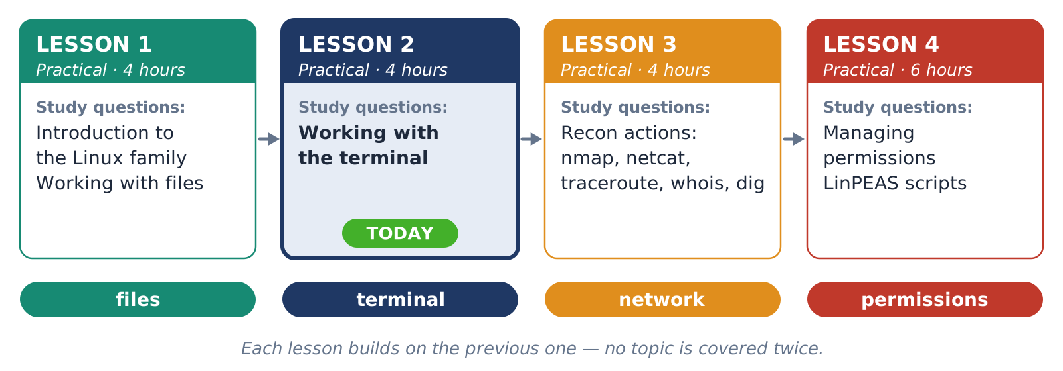
Figure 1. Map of the lessons of Topic 2: today – Lesson 2
Table 2. Distribution of lesson time (2 sessions × 80 minutes)
Part | Content | Time
1st SESSION |  | 80 min.
I. Introduction | Checking attendance and readiness, announcing the topic and objective, safety rules, starting the VM and taking a snapshot | 10 min.
II. Main part | Theory explanation: based on the diagrams of sections 1.1–1.14 (20 min.)  Tasks 1–5: shell, syntax, PATH, help system, history and shortcut keys (40 min.) | 60 min.
III. Final part | Checking the results, answering questions, announcing the task of the next session | 10 min.
2nd SESSION |  | 80 min.
I. Introduction | Attendance, a short review of the 1st session, checking the state of the VM | 10 min.
II. Main part | Tasks 6–13: redirection, pipes and filters, operators, variables, processes, packages, services, bash script | 60 min.
III. Final part | Checking that the objective is achieved, cleaning up the laboratory, grading, an assignment for independent preparation | 10 min.

Ground rules
• All actions are performed only in the Kali Linux virtual machine. At the start of the lesson take a snapshot named “Lesson-2.2 start”.
• Type the commands that use sudo exactly as shown in the task. sudo and permissions are covered in detail in Lesson 4.
• Before running a command found on the internet, make sure you understand every word of it.
• All practice files are created in the ~/lab22 directory and deleted at the end of the lesson.

How to work with this guide
• Part I – theory. Every concept is explained with diagrams and examples. Before a task, read the corresponding section (the task shows “Theory: 1.x”).
• Part II – practical workbook. Each task: objective and time → steps → space for a screenshot → all possible results → conclusion.
• In code blocks $ is the abbreviation of the prompt – do not type it. Grey text after # is a comment.
• Terminal outputs are examples: PIDs, dates, versions and sizes will differ on your machine – this is normal.

PART I. THEORY: WORKING WITH THE TERMINAL
In Lesson 1 we used the terminal as a tool for working with files. Now we study the terminal itself: how typed text becomes a command, where the output goes, how commands combine, and how to manage processes, programs and services from the terminal. The daily work of a cybersecurity specialist – analysing logs, inspecting a system, launching tools – is done mostly in the terminal.

1.1. Terminal, console and shell: who does what?
In everyday speech “terminal”, “console”, “shell” and “command line” are used interchangeably, but they are different things. You type text on the keyboard – the terminal emulator (in Kali, the QTerminal window) receives it and passes it to the shell. The shell is the program that understands commands: it splits the text into words, expands special characters and starts the required program. The program uses the disk, memory or network through system calls to the kernel and returns the result – the result appears in the terminal window.
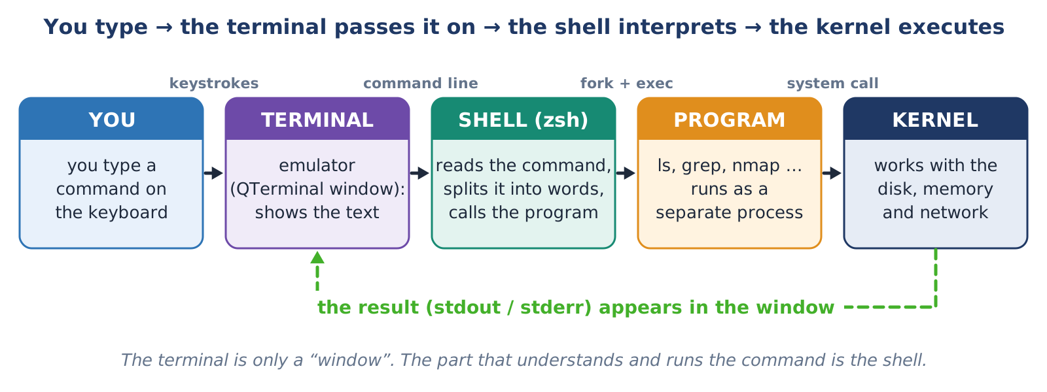
Figure 2. The path of a command: from the keyboard to the kernel and the return of the result
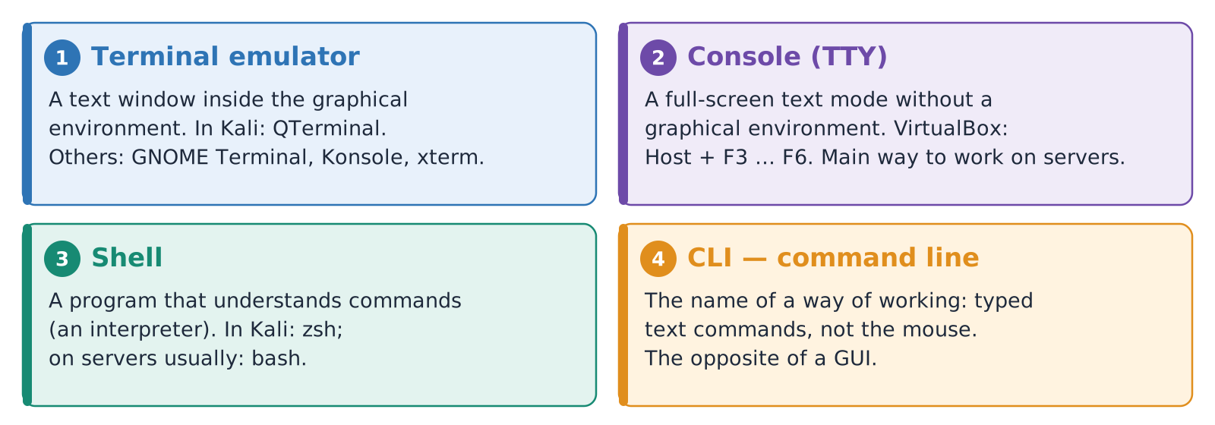
Figure 3. Four concepts: terminal emulator, console (TTY), shell and CLI
The console (TTY) is a text mode without a graphical environment that occupies the whole screen. A graphical environment is often not installed on servers, so the administrator logs in to the system through the console or SSH. Even while the graphical environment is running, Kali keeps several virtual consoles ready; in VirtualBox you switch to them with Host + F3 … F6 ( Host is usually the right Ctrl ). The tty command shows which “screen” you are working on: /dev/pts/0 in a graphical terminal, /dev/tty3 and similar in a virtual console.
Table 3. The most common shells
Shell | In brief | Where it is found
bash | Bourne Again Shell – the most widespread | Ubuntu, Debian, servers, most scripts
zsh | Compatible with bash, with extra conveniences: suggestions, colour, powerful completion | Kali Linux (default since 2020.4), macOS
sh / dash | The simplest and fastest, the POSIX standard | System scripts, minimal containers
fish | Friendly, but not fully compatible with bash | Personal use
PowerShell | A shell that works with objects | Windows (Topic 1); can also be installed on Linux

Remember
• When a terminal opens in Kali, zsh runs; on servers and in most tutorials it is bash. The basic commands are the same in both; the differences are pointed out separately in this guide.
• To find out the current shell: echo $SHELL (the shell started at login) and echo $0 (the shell running right now).
• If you type bash inside zsh, bash starts; type exit to leave it and return to zsh.

1.2. The prompt and Kali zsh features
The prompt is the shell’s sign that it is “waiting for a command”. It tells you at a glance who you are working as, on which computer and in which directory. In Kali the prompt has two lines: the first holds the information, the second is where you type the command. The last character matters: $ – a normal user, # – root (the administrator). A wrong command run as root can affect the whole system, so Kali shows the root prompt in red.
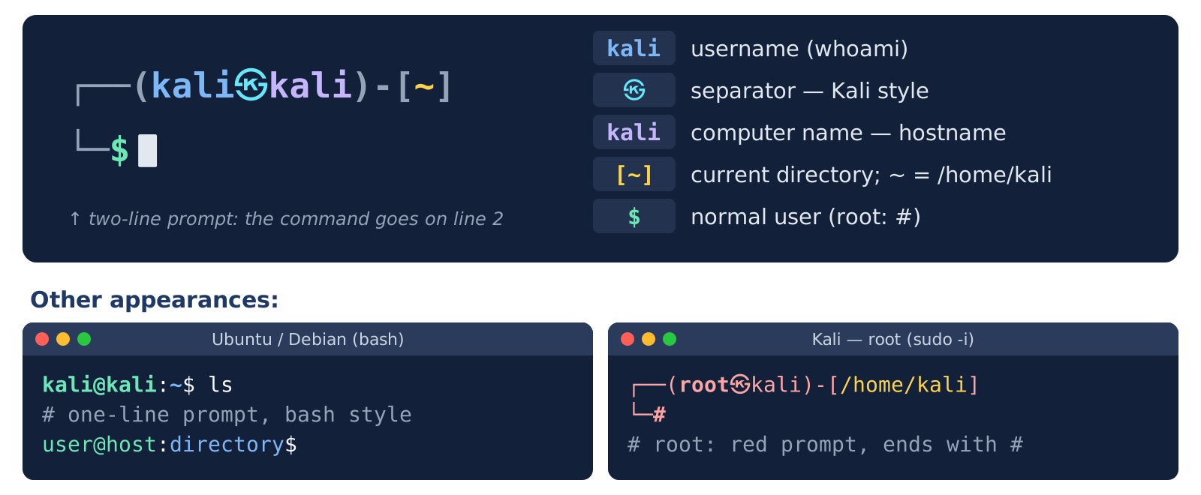
Figure 4. The structure of the Kali prompt and its other appearances
The zsh configuration in Kali enables two useful helpers. Autosuggestion: as you start typing, zsh suggests a matching command from history in grey text – press → or End to accept it. Syntax colouring: the command name is green if it exists and red if it does not – you notice the mistake before pressing Enter .
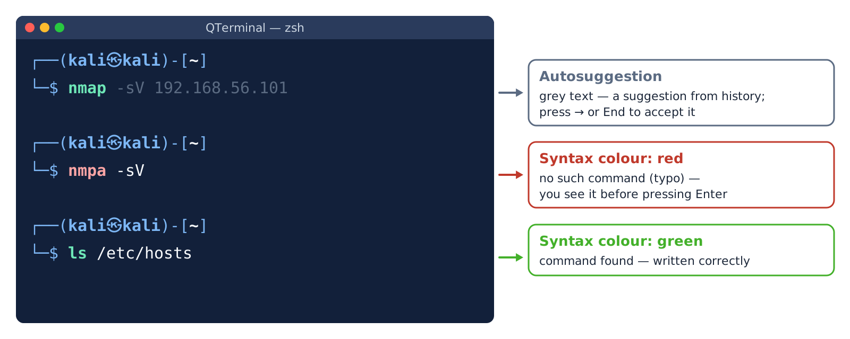
Figure 5. Kali zsh: autosuggestion and syntax colouring
Useful Kali zsh settings
• Ctrl + P – switches the prompt between the two-line and the one-line appearance (handy for screenshots).
• If you type a command that does not exist, Kali may suggest which package installs it: Command 'sl' not found, but can be installed with: sudo apt install sl.
• The settings are stored in the ~/.zshrc file (section 1.10).

1.3. Command syntax: command, option, argument and quotes
Every command has the same structure: the command (what to do), options or flags (how to do it) and arguments (what to act on). Options are written in two ways: short (-l – one dash and one letter) and long (--all – two dashes and a whole word). Short options can be combined: ls -l -a and ls -la are the same. Some options take a value: head -n 5 or --sort=size.
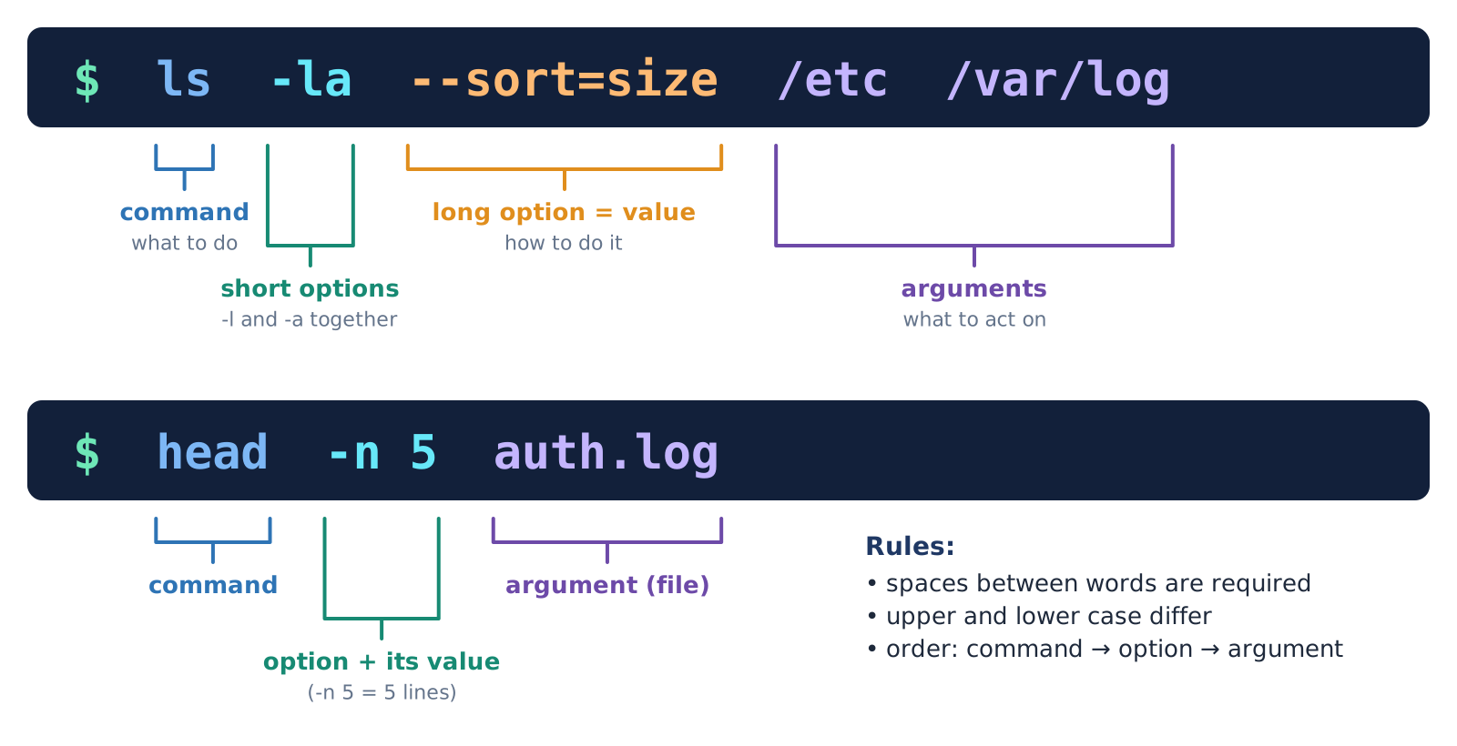
Figure 6. The parts of a command line
Before executing a command the shell splits the line into words – the separator is a space. Then it expands special characters: $HOME is replaced with /home/kali, ~ with the home directory, *.txt with the list of matching files. If a file name contains a space and is not put in quotes, the shell understands it as two separate words – this is the most common beginner’s mistake.
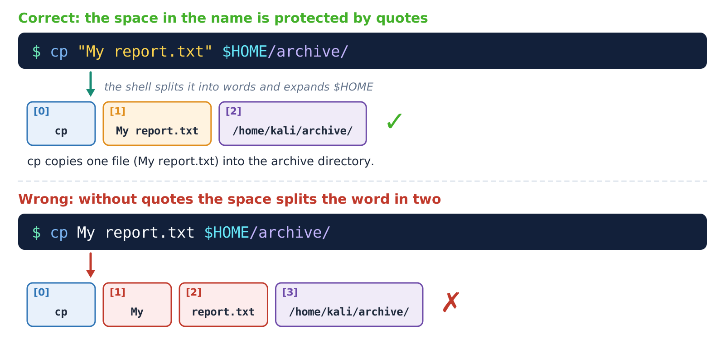
Figure 7. How the shell splits a line into words: with quotes and without quotes
Table 4. Quotes and special characters
What you type | Result (when USER=kali) | Rule
echo "Hello $USER" | Hello kali | Double quotes: the variable is expanded, spaces are preserved
echo 'Hello $USER' | Hello $USER | Single quotes: everything is literal
echo Hello \$USER | Hello $USER | A backslash protects a single character
echo "Today is $(date +%A)" | Today is Friday | $( ) – the output of the command inside is inserted
echo ~ | /home/kali | ~ – the home directory (not expanded inside quotes)

Three rules about options
• Upper and lower case differ: ls -r (reverse order) and ls -R (with subdirectories) are different options.
• The same letter means different things in different commands: -n is “number of lines” in head, “line number” in grep, “as a number” in sort. That is why you must check the manual of each command (section 1.5).
• The -- sign means “options end here”: rm -- -file.txt deletes a file whose name begins with a dash.

1.4. Where a command is found: command types and PATH
When you type ls, the shell has to find this name. It searches in a strict order: first an alias (abbreviation), then a shell keyword (if, for), then a user function, then a shell builtin (cd, echo, export) and finally a program file on disk. A program file is searched for in the directories listed in the PATH variable, from left to right; the first one found is executed. If it is found nowhere – the “command not found” message and exit code 127.
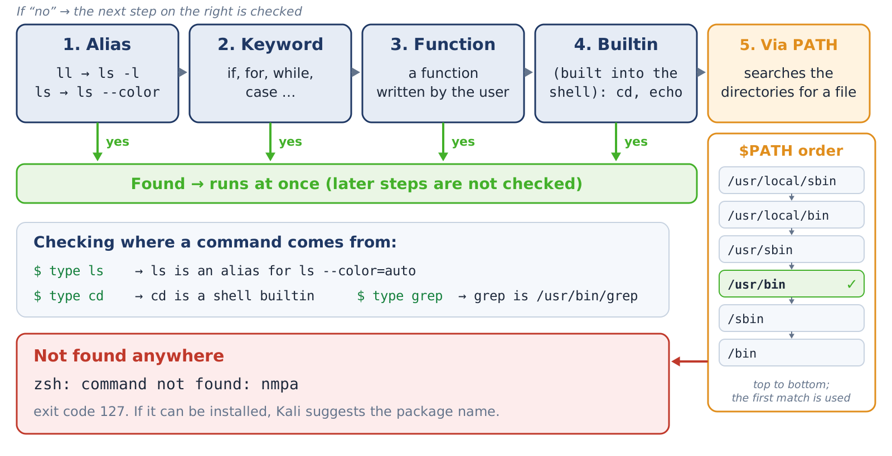
Figure 8. The order in which the shell searches for a command, and the PATH directories
$ echo $PATH
/usr/local/sbin:/usr/local/bin:/usr/sbin:/usr/bin:/sbin:/bin:/usr/games
$ echo $PATH | tr ':' '\n' # each directory on its own line
$ type -a ls # all sources of ls
ls is an alias for ls --color=auto
ls is /usr/bin/ls
ls is /bin/ls
Why must cd be a builtin? Because it changes the shell’s own current directory. If cd were a separate program, it would change the directory of its own process only and then finish, while the shell would stay where it was. For the same reason export, alias and exit are builtins too.
Practical advice
• Add only trusted directories to PATH; do not add the current directory (.) – otherwise it becomes hard to control which program is being run.
• On an unfamiliar system, checking where a command comes from with type -a or which -a is a good habit.

1.5. Getting help: man, --help, help and apropos
Linux has hundreds of commands and thousands of options – you do not have to memorise them. What matters is to know how to find the needed information quickly. There are four tools for this: man (the full manual), --help (a short list), help (for bash builtins) and apropos / man -k (searching for a command by keyword).
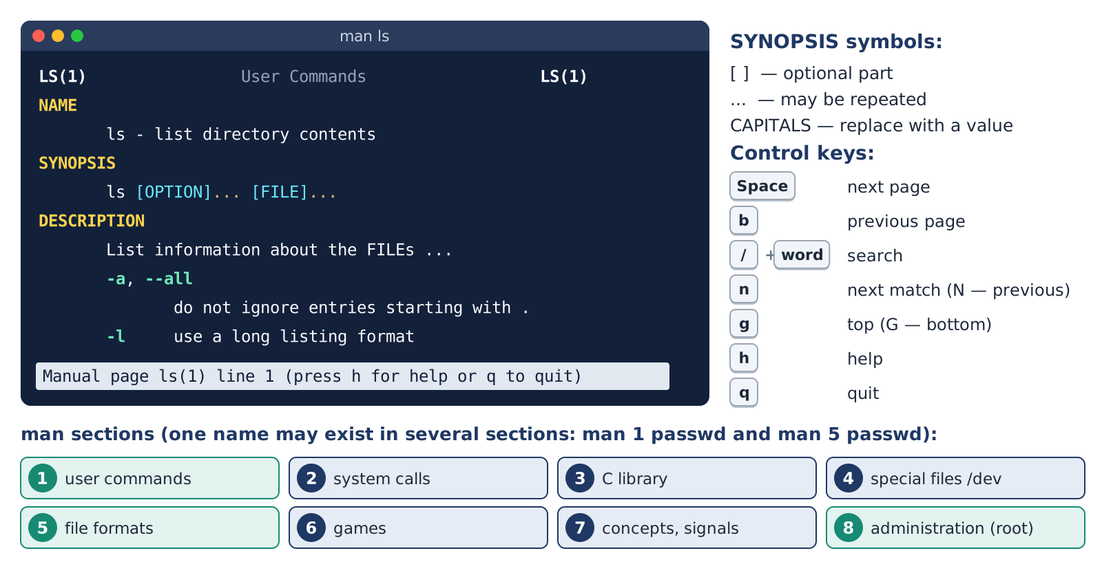
Figure 9. The structure of a man page, its control keys and sections
Table 5. Which tool for which situation
Tool | When to use it | Example
man command | You need the full, official manual | man grep
command --help | You need to recall the options quickly | ls --help
help command | bash builtins (cd, export); zsh has no such command | bash -c 'help cd'
man -k word | You do not know the command name, only its purpose | man -k compress
whatis command | A one-line description | whatis tar
man 5 file | The format of a configuration file | man 5 passwd

Reading long output
• If the --help output scrolls off the screen too fast, pass it to less: ls --help | less (| – section 1.8).
• Inside man, type / and a word to search, and press n to jump to the next match. The fastest way to find an option: /-r or /--recursive.
• Kali tools have manuals too: man nmap – you will need it in Lesson 3.

1.6. Working fast: Tab, command history and shortcut keys
Working fast in the terminal means not typing a lot but typing little. Tab completion: type the beginning of a command or file name and press Tab – the shell writes the rest; if there are several options it shows the list. This also protects from mistakes: if the name is not completed, such a file does not exist. History: every command is saved, you go back to them with ↑ and ↓ , and search the history with Ctrl + R . Editing keys: move the cursor word by word or to the start or end of the line, delete a word or part of a line with one keystroke.
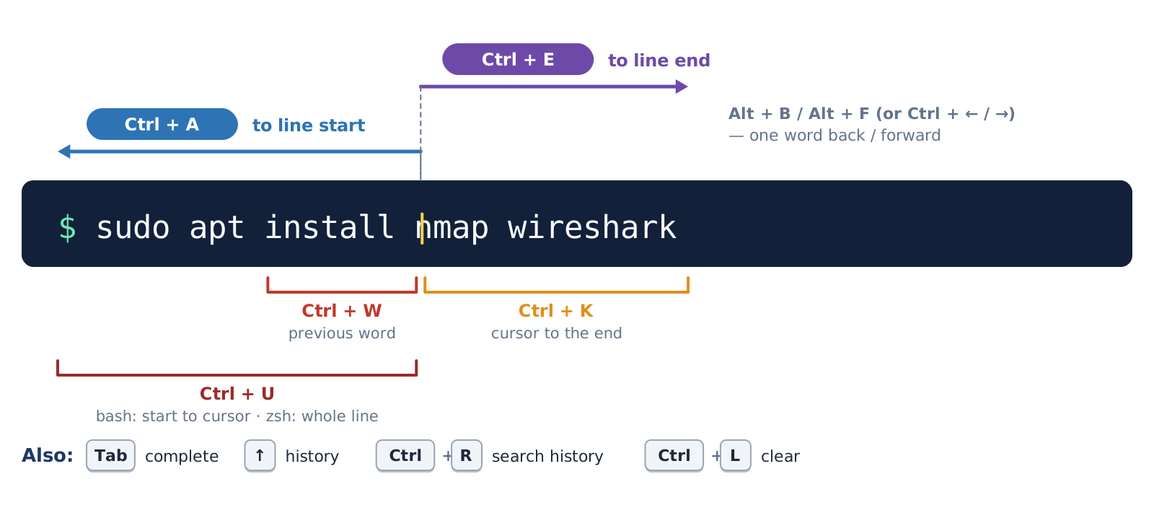
Figure 10. Keys for editing the command line
Table 6. The most useful shortcut keys
Key | Function | Note
Tab | Complete a name | Pressed twice – the list of options
↑ / ↓ | Previous / next command | Moving through the history
Ctrl + R | Search the history | Ctrl + R again – the next match
Ctrl + C | Stop the running command | NOT “copy” in the terminal
Ctrl + Shift + C / V | Copy / paste | In the terminal window
Ctrl + L | Clear the screen | Same as clear
Ctrl + D | End of input (EOF) | On an empty line – leaves the shell
Ctrl + Z | Suspend the command temporarily | Section 1.11: fg, bg
Ctrl + S / Q | Freeze / resume screen output | If the terminal “froze” – Ctrl + Q

$ history | tail -5 # the last 5 commands
$ history 1 # zsh: the whole history
$ !! # repeat the last command
$ !42 # command number 42 in the history
$ sudo !! # the last command with sudo
What to know about history
• zsh stores the history in ~/.zsh_history, bash in ~/.bash_history. Commands are written to the file when the terminal is closed or immediately.
• In Kali zsh, expansions such as !! are not executed immediately: first the expanded command is shown on the line, and you check it and press Enter .
• History is a valuable source: it is one of the first files examined when reconstructing what was done on a system (in forensics). So never type a password inside a command – it stays in the history in clear text.

1.7. Input and output streams and redirection
Every running program has three standard “pipes” – streams. stdin (number 0) is the input, usually the keyboard. stdout (1) is the normal output, usually the screen. stderr (2) carries error messages, and it also usually goes to the screen. On the screen, output and errors look the same, but they are separate streams: so they can be redirected to different files, or one of them can be discarded.
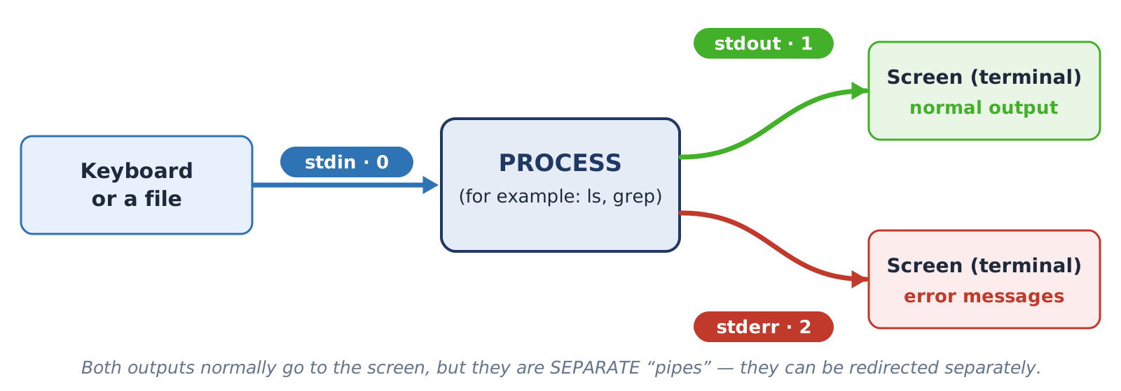
Figure 11. The three standard streams: stdin, stdout and stderr
Redirection means turning a stream away from the screen to a file (or from a file). > writes to a file and erases the old content, >> appends to the end of a file, 2> redirects only errors, &> writes output and errors to one file, and < gives the command its data from a file instead of the keyboard. The special /dev/null file is a “black hole”: everything written to it disappears; it is used to hide unwanted error messages.
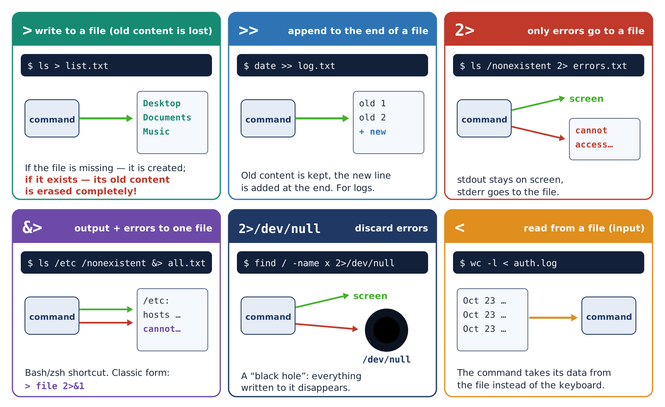
Figure 12. Redirection operators and what they do
Table 7. Redirection operators – the full list
Operator | What it does | Example
> | stdout to a file, old content is erased | ls > list.txt
>> | stdout appended to the end of a file | date >> log.txt
2> | stderr to a file | ls /nonexistent 2> errors.txt
2>> | stderr appended to the end of a file | cmd 2>> errors.log
&> | stdout and stderr to one file (bash/zsh) | cmd &> all.txt
> f 2>&1 | The same – the classic form, in any shell | cmd > f.txt 2>&1
2>/dev/null | Discard errors | find / -name x 2>/dev/null
< | stdin from a file | wc -l < auth.log
<< 'EOF' | Entering multi-line text (here-doc) | cat > f.txt << 'EOF'
| tee f | The output both to the screen and to a file | ls | tee list.txt

Three important subtleties
• Order matters. cmd > f 2>&1 – both streams go to the file. cmd 2>&1 > f – the error stays on the screen, because when 2>&1 was evaluated, stdout was still pointing to the screen.
• `sudo` does not affect redirection. sudo echo x > /etc/f does not work: the > is performed by your ordinary shell. The correct way: echo x | sudo tee /etc/f.
• A lone `> file` in zsh does not create an empty file – it waits for input from the keyboard (finish it with Ctrl + D ). Use touch for an empty file.

1.8. Pipes and filter commands
A pipe (the | sign) connects the stdout of one command to the stdin of the next. This is the foundation of the Linux philosophy: each program does one job well, and a complex task is solved by chaining small programs. For example, from an 18-line log the needed lines are first selected, then the IP address is cut out of them, sorted and counted – and you see how many failed login attempts came from each address.
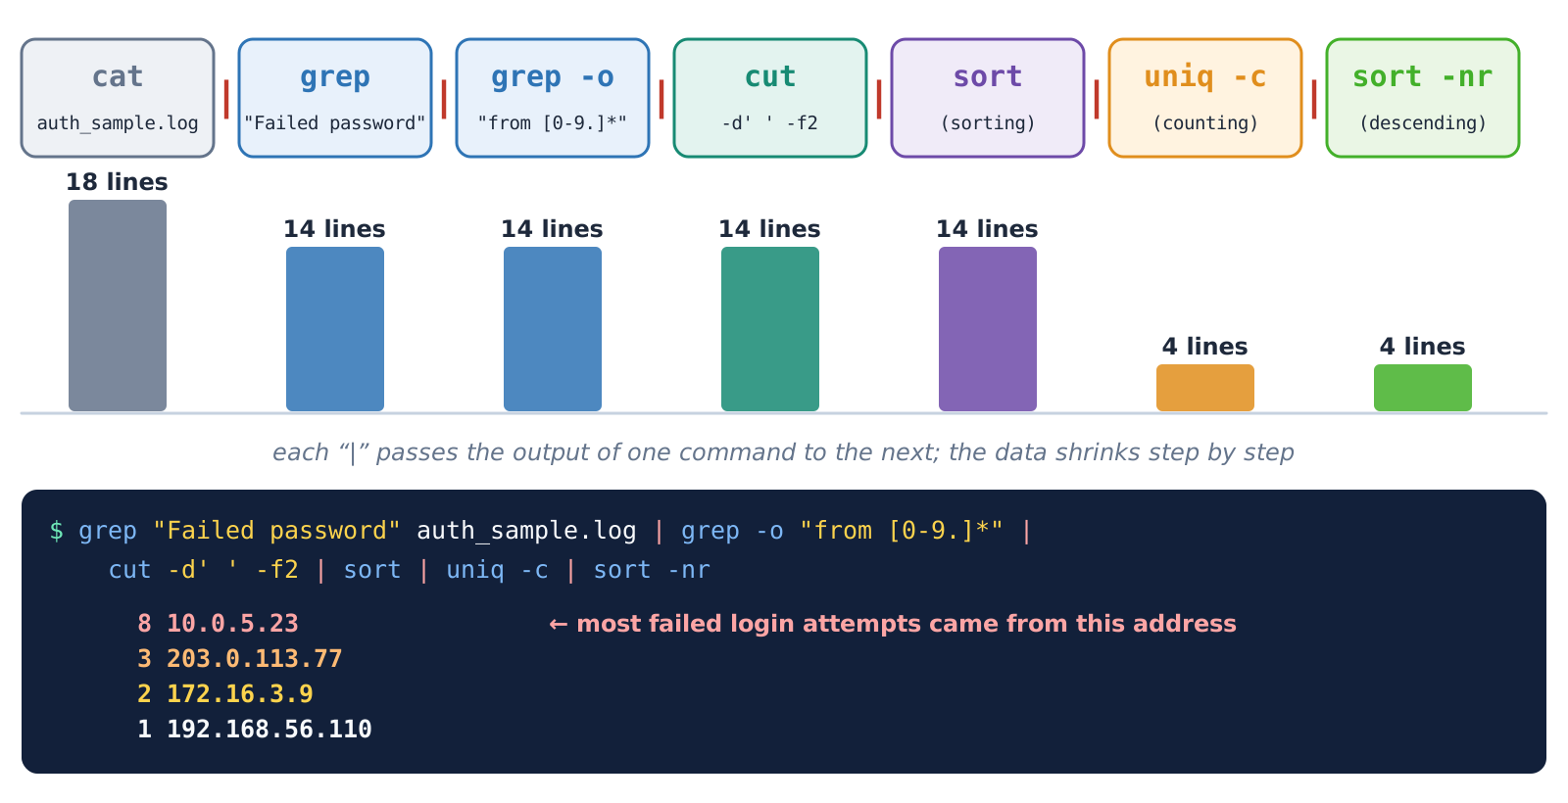
Figure 13. A pipeline: the data shrinks at every step
Table 8. Filter commands
Command | Function | Main options
grep pattern | Prints the lines containing the pattern | -i ignore case, -v invert, -n line number, -c count, -o only the matching part, -E extended pattern, -r recursive through directories
sort | Sorts lines | -n numeric, -r reverse, -u unique, -t: -k3 by the 3rd field, -h 1K/1M
uniq | Merges consecutive duplicates | -c count, -d only the repeated ones. sort first!
cut | Cuts out a column (field) | -d':' delimiter, -f1,7 fields, -c1-10 characters
wc | Counts | -l lines, -w words, -c bytes
tr | Replaces or deletes characters | tr 'a-z' 'A-Z', -d delete, -s squeeze
head / tail | The beginning / the end | -n 5; tail -f – follow new lines
tee | Splits the stream in two | -a – append to the file

How to build a pipeline
• Do not write the whole chain at once. Write the first command and look at the output, then add one step at a time with | and check the output each time.
• If an intermediate output is long, temporarily add | head at the end.
• sort | uniq -c | sort -nr is the classic chain that answers “how many times did each thing occur and which is the most frequent”.

1.9. Combining commands and the exit code
When a command finishes, it returns an exit code to the shell: 0 – success, a non-zero number – an error. The code of the last command is stored in the $? variable. Based on this code, commands can be combined conditionally: ; – runs the next command regardless of how the previous one ended; && – only if the previous one succeeded; || – only if the previous one ended with an error.
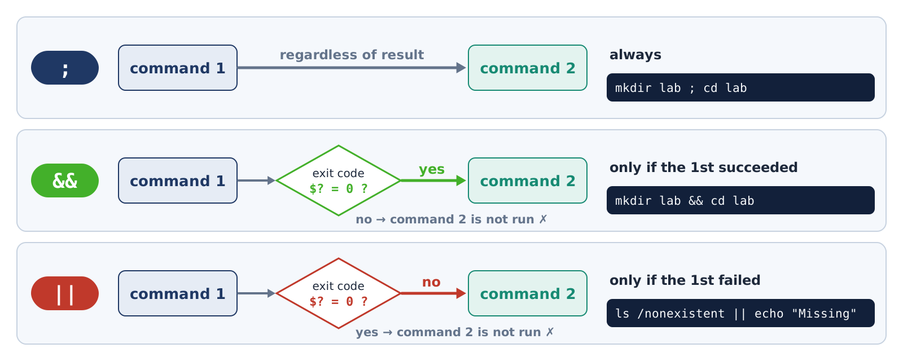
Figure 14. The ;, && and || operators
Table 9. Common exit codes
Code | Meaning | Example
0 | Success | ls /etc; echo $? → 0
1 | General error; in grep – nothing was found | grep -q zzz /etc/passwd; echo $? → 1
2 | Incorrect usage or a serious error | ls /nonexistent; echo $? → 2
126 | The file exists but cannot be executed | A script without execute permission
127 | Command not found | nmpa; echo $? → 127
130 | Stopped with Ctrl + C (128 + 2) | sleep 60, then Ctrl + C
137 | Forcibly killed (128 + 9) | After kill -9

1.10. Variables, aliases and configuration files
A variable is a value bound to a name. It is created as NAME=value (there must be no spaces around the equals sign!) and read with $NAME. An ordinary variable is visible only in the current shell. A variable that is exported becomes an environment variable and is inherited by all programs started from this shell. The system environment variables – PATH, HOME, USER, SHELL, PWD, LANG – tell programs where they run, for whom they run and in which language to respond.
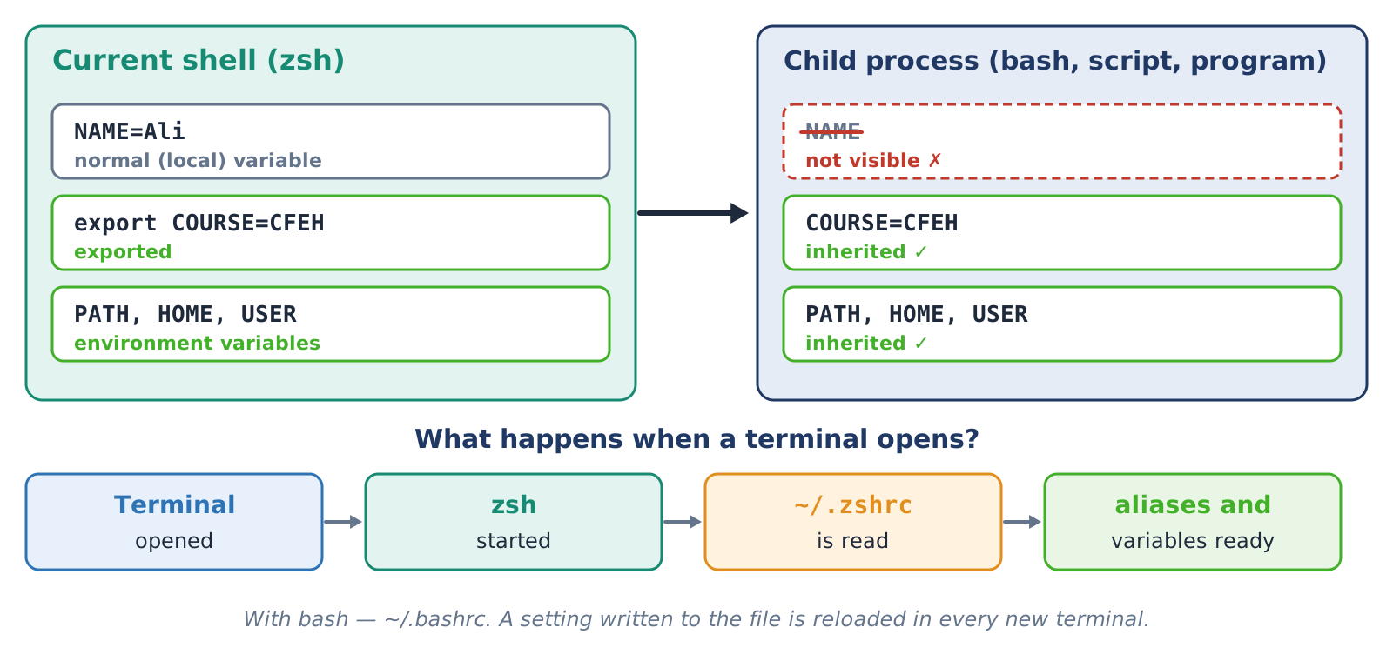
Figure 15. An ordinary and an exported variable; loading of the settings when a terminal opens
$ NAME="Ali" # an ordinary variable
$ echo "Hello, $NAME"
Hello, Ali
$ export COURSE="CFEH" # an environment variable
$ bash -c 'echo "$NAME | $COURSE"' # inside a new process
| CFEH
$ TODAY=$(date +%F); echo $TODAY # saving a command output
2026-10-23
$ echo $((7 * 24)) # arithmetic
168
An alias is a short name for a long command: alias ll='ls -l'. Kali comes with several aliases ready (ll, la, l, coloured ls and grep) – the alias command lists them. When the terminal is closed, variables and aliases created by hand disappear. To make them permanent they are written to the shell configuration file: ~/.zshrc for zsh, ~/.bashrc for bash. These files are read every time a new terminal opens; to apply the change to the current terminal at once, type source ~/.zshrc.
Table 10. Important environment variables
Variable | Meaning | Sample value
HOME | Home directory | /home/kali
USER | Current user | kali
SHELL | Login shell | /usr/bin/zsh
PATH | Directories searched for programs | /usr/local/sbin:…:/bin
PWD / OLDPWD | Current / previous directory | /home/kali/lab22
LANG | Language and encoding | en_US.UTF-8
EDITOR | Default text editor | nano

The habit of checking configuration files
• ~/.zshrc and ~/.bashrc are executed every time a terminal opens. For this reason, when inspecting a system it is useful to look at their last modification time and content: if a foreign alias or command has been added, it runs every time.
• Make a copy before changing: cp ~/.zshrc ~/.zshrc.bak.

1.11. Processes, signals and background mode
A process is a running program. Each process has a unique number – the PID – and the number of the parent process that started it – the PPID. All processes form a tree whose root is systemd (PID 1). Every command you type in the terminal is a child process of your shell. Processes can be viewed with ps, pstree and, in real time, top / htop; every process is also reflected in the /proc/PID/ directory.
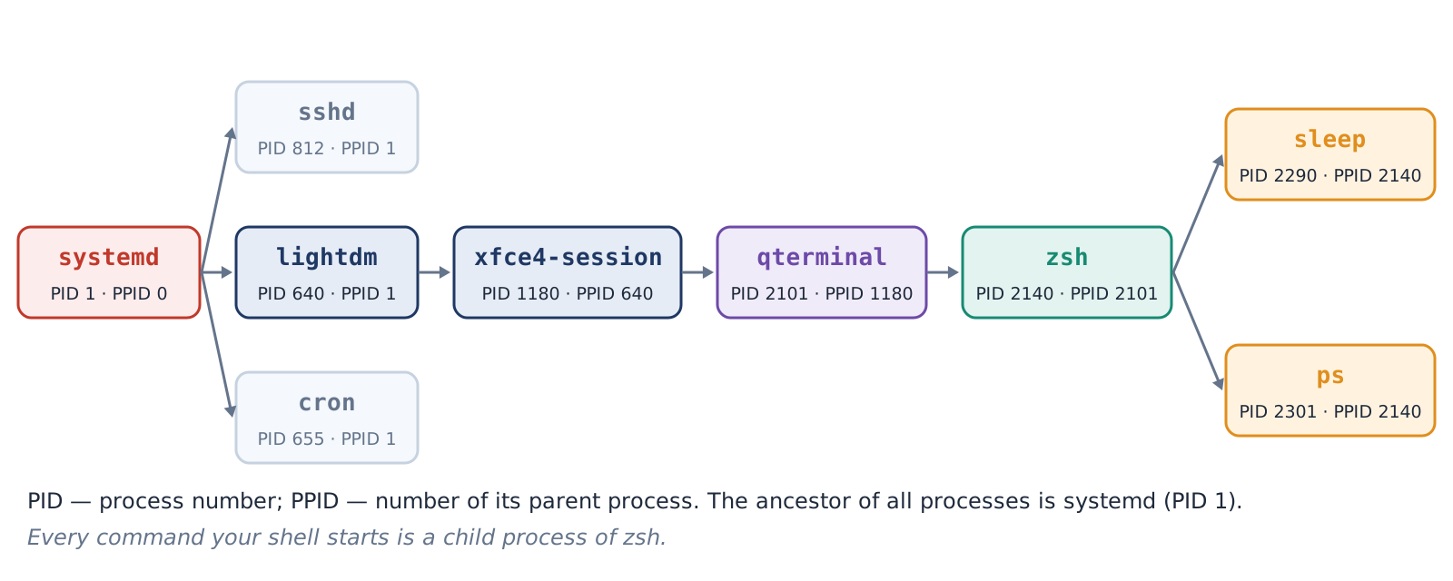
Figure 16. The process tree: PID and PPID
Table 11. Columns of ps aux
Column | Meaning
USER | The owner of the process
PID | The process number
%CPU / %MEM | Share of processor and memory
VSZ / RSS | Virtual and actually used memory (KB)
TTY | Which terminal it is attached to (? – no terminal, a background service)
STAT | State: R running, S sleeping, T stopped, Z zombie, D waiting for disk; + foreground, s session leader
START / TIME | Start time / processor time used
COMMAND | The full command line

A process can be controlled by sending it a signal. kill PID by default sends SIGTERM (15) – “please finish your work”: the program saves its files and exits in an orderly way. kill -9 PID is SIGKILL: the kernel kills the process at once and the program cannot save anything; it is the last resort. To work by name there are pgrep (find) and pkill (send a signal).
Table 12. The main signals
Signal | Number | When it is sent | Can the program refuse it
SIGHUP | 1 | The terminal was closed; many services re-read their configuration | Yes
SIGINT | 2 | Ctrl + C | Yes
SIGKILL | 9 | kill -9 – forced termination | No
SIGTERM | 15 | kill (default) – orderly termination | Yes
SIGCONT | 18 | fg, bg – continue | –
SIGSTOP | 19 | Forced suspension | No
SIGTSTP | 20 | Ctrl + Z | Yes

If you put & at the end of a command, it runs in the background and the terminal becomes free at once. A command running in the foreground can be suspended with Ctrl + Z and then continued in the background with bg or in the foreground again with fg. jobs shows the list of background jobs in the current terminal; they are referred to as %1, %2 and so on.
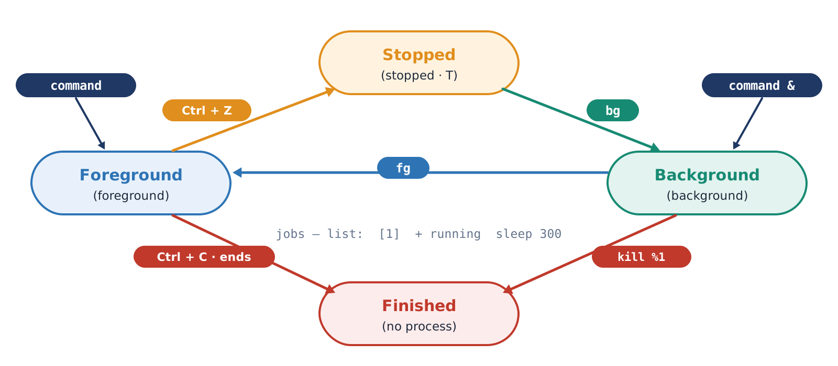
Figure 17. Managing background jobs (job control)

1.12. Installing programs: apt and dpkg
On Linux, programs are installed not by downloading an installer file from the internet, but through a package manager. In the Debian family (Kali is in this family too) this is apt. Programs are stored in a repository – a store of packages that the distribution’s developers have checked and signed with a digital signature. apt update refreshes the list of packages in the repository, and apt install downloads and installs a package together with the other packages it needs (its dependencies). Internally the installation is done by dpkg.
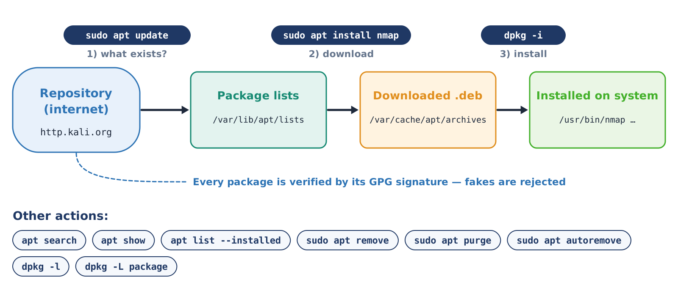
Figure 18. How apt works: from the repository to the system
Table 13. apt and dpkg commands
Command | Function | Needs sudo
apt update | Refresh the package list | Yes
apt list --upgradable | Packages that can be upgraded | No
apt full-upgrade | Upgrade all packages (recommended by Kali) | Yes
apt search word | Search for a package by name or description | No
apt show package | Information about a package: version, size, dependencies | No
apt install package | Install | Yes
apt remove package | Remove (configuration files stay) | Yes
apt purge package | Remove completely, together with its configuration | Yes
apt autoremove | Clean up dependencies that are no longer needed | Yes
dpkg -l | All installed packages | No
dpkg -L package | Which files a package installed | No
dpkg -S /path/file | Which package a file belongs to | No

A short note on sudo
• Installing a program changes the whole system, so administrator rights are needed. sudo runs one command with root rights.
• sudo asks for your own password (in the Kali VirtualBox image – kali). While you type the password nothing appears on the screen – this is normal.
• The features of sudo and its safe configuration are covered in detail in Lesson 4.

1.13. Services: systemd and systemctl
A service (on Linux often called a “daemon”) is a program that runs permanently in the background: an SSH server, a web server, time synchronisation, logging. In Topic 1 we learned that Windows services are managed by the Service Control Manager. In modern Linux this job is done by systemd – it starts as PID 1 and manages all services (units). You work with them through the systemctl command, and the service logs are shown by journalctl.
A service has two independent states, and telling them apart is very important. The current state – active (running) or inactive (stopped); it changes with start / stop. The boot state – enabled (starts automatically when the computer is turned on) or disabled; it changes with enable / disable. That is, a service may be running now but not start at the next boot – and the other way round.
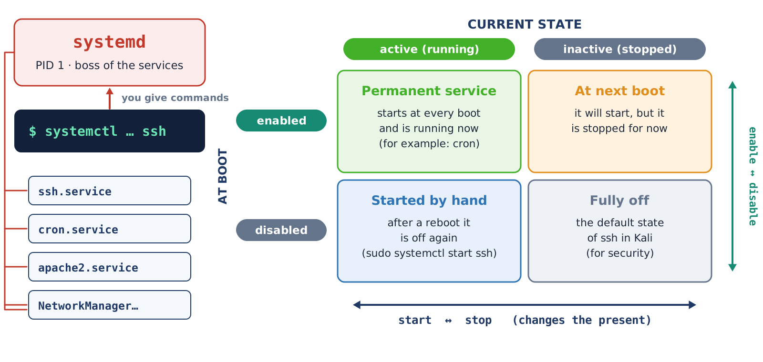
Figure 19. systemd: the current state and the boot state
Table 14. Windows and Linux: working with services
Task | Windows (Topic 1) | Linux (systemd)
List of services | services.msc, Get-Service | systemctl list-units --type=service
Viewing the state | Get-Service ssh-agent | systemctl status ssh
Start / stop | Start-Service / Stop-Service | sudo systemctl start / stop
Automatic start | Startup type: Automatic | sudo systemctl enable
Turning off | Startup type: Disabled | sudo systemctl disable (fully: mask)
Service log | Event Viewer | journalctl -u ssh

Why is SSH off in Kali?
• In Kali, network services including SSH are off by default (disabled, inactive). This is a security policy: the VirtualBox image has a default password (kali), and an open SSH would let anyone on the network connect.
• That is why in Task 12 SSH is turned on only for a short time to study the states, and it is definitely stopped at the end.

1.14. Bash script basics
A script is a text file with a sequence of commands. Instead of typing the same 5–10 commands by hand every day, they are written to one file and run with a single command. The first line of a script is the shebang (#!/bin/bash): it tells the system which program should execute the file. Other lines beginning with # are comments. Everything you learned in the terminal works in a script: variables, $( ), redirection and pipes.
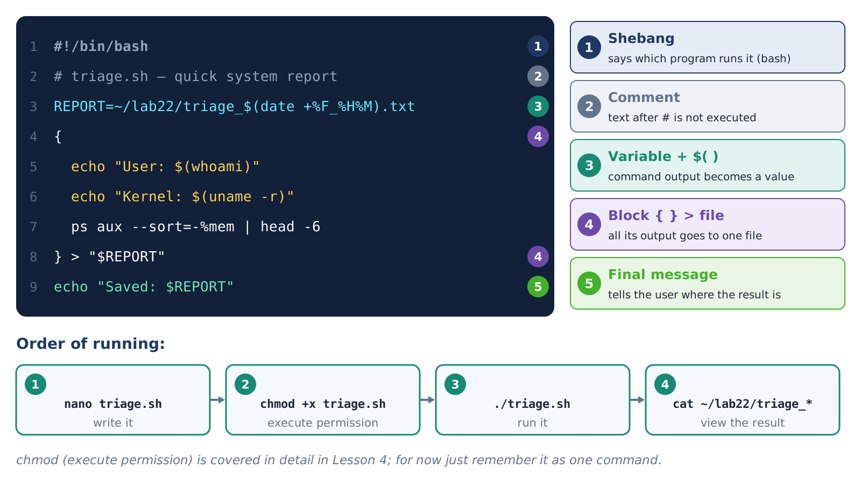
Figure 20. The structure of a simple bash script and the order of running it
There are two ways to run a script. The first is bash triage.sh: the file does not need any special permission. The second is ./triage.sh: the file must first be given execute permission (chmod +x triage.sh). The ./ sign means “the file in the current directory” – because the current directory is not in PATH, it must be specified explicitly.
Table 15. Special variables in a script
Symbol | Meaning | Example
$0 | The name of the script | ./triage.sh
$1, $2 … | The 1st, 2nd argument given to the script | ./hello.sh Ali → $1 = Ali
$# | The number of arguments | ./hello.sh Ali Vali → 2
$? | The exit code of the last command | 0 – success
$$ | The PID of the current process (script) | 4521

PART II. PRACTICAL WORKBOOK

Preparation: checking the laboratory environment
1. Start the Kali Linux virtual machine in VirtualBox (login kali, password kali).
2. Take a snapshot named “Lesson-2.2 start” (Machine → Take Snapshot).
3. Open the terminal: Ctrl + Alt + T or the terminal icon on the top panel.
4. Create the practice directory and go into it:
$ mkdir -p ~/lab22 && cd ~/lab22
$ pwd
/home/kali/lab22
How you complete each task
• Perform the steps in order and compare the result with the sample in the code blocks.
• Put a picture of your own terminal window in the screenshot space (for example with ShareX or Print Screen ).
• In the “Predict, then check” tables, write your own answer first, then check it in the terminal.

Task 1. Getting to know the terminal, the shell and the console
Objective: To determine which shell and which terminal you are working in. · Time: 6 min · Theory: 1.1, 1.2
1. Look at the current shell and all the shells on the system:
$ echo $SHELL # the login shell
/usr/bin/zsh
$ echo $0 # the shell running right now
zsh
$ cat /etc/shells # list of installed shells
$ tty # which terminal device
/dev/pts/0
2. Switch to bash, watch how the prompt changes, then go back: bash → echo $0 → exit → echo $0.
3. Press Ctrl + P to switch the Kali prompt to the one-line appearance; press it again – it returns.
4. Switch to a virtual console: Host + F3 . Log in with kali / kali, type tty (the result is /dev/tty3), leave with exit and return to the graphical environment with Host + F7 (on some systems F1 or F2 ).
▢ Screenshot 1. The results of echo $SHELL, echo $0, tty and the appearance of the bash prompt
(paste a screenshot of your own result here)

Table 16. All possible results
Command / situation | Result | Note
echo $0 in zsh | zsh or -zsh | - means it is a login shell
echo $0 in bash | bash | bash started inside zsh
tty in a graphical terminal | /dev/pts/0, /dev/pts/1 … | Every new window gets a new number
tty in a virtual console | /dev/tty3 … /dev/tty6 | Matches the F-key number
The bash prompt | kali@kali:~$ | One line, without the Kali colours
A black screen after Host + F7 | The graphical environment is on another console | Try Host + F1 or F2
exit typed many times | The terminal window closes | You left the outermost shell

Conclusion – Task 1
Meaning: The terminal is the window, the shell is the program that understands commands. The shell can be changed inside one window; the look of the prompt tells which shell and which user is working.
Where and when it is needed: When connecting to a server, the first thing to look at is which shell you are in and who you are logged in as. If the graphical environment stops working, a virtual console may be the only way to repair the system.

Task 2. Command syntax and quotes
Objective: To see in practice the effect of options, arguments and quotes. · Time: 8 min · Theory: 1.3
1. Compare the options of the same command:
$ ls /etc | head -3 # plain
$ ls -l /etc | head -3 # detailed
$ ls -lh --sort=size /var/log | head -4 # by size
$ date # date and time
$ date +%F # date only: 2026-10-23
$ date "+%d.%m.%Y %H:%M" # day.month.year format
2. Fill in the table below by predicting first, then check:
Table 17. Predict, then check
Command | Your prediction | Actual result
echo "Home: $HOME" |  | Home: /home/kali
echo 'Home: $HOME' |  | Home: $HOME
echo Home: $HOME |  | Home: /home/kali (the spaces shrink to one)
echo "Home: $HOME" |  | Home: /home/kali (the spaces are preserved)
echo "Year: $(date +%Y)" |  | Year: 2026

3. Work with a name that contains a space:
$ touch "my report.txt"
$ ls -l my report.txt # wrong: two files are searched for
$ ls -l "my report.txt" # correct
$ ls -l my\ report.txt # correct: \ protects the space
▢ Screenshot 2. The results of ls -l with quotes and without quotes
(paste a screenshot of your own result here)

All possible results and errors
• ls: cannot access 'my': No such file or directory – the quotes were forgotten, the name was split in two.
• ls: invalid option -- 'z' – a non-existent option was typed; find the right one with ls --help.
• If a quote is not closed (echo "hello), zsh waits for the rest with the dquote> sign – cancel with Ctrl + C .
• In zsh echo "a\nb" prints on two lines, while in bash it stays as a\nb. For the same result in both, use printf "a\nb\n".

Conclusion – Task 2
Meaning: Before executing a command, the shell splits the line into words and expands special characters; quotes control this process.
Where and when it is needed: Quote mistakes are the most common problem in file names, passwords, search patterns and variables in scripts. The rule: always put a variable in double quotes – "$FILE".

Task 3. Command types and PATH
Objective: To find out where a command comes from and to add your own directory to PATH. · Time: 10 min · Theory: 1.4
1. Find out the type of different commands:
$ type cd ls ll grep if
cd is a shell builtin
ls is an alias for ls --color=auto
ll is an alias for ls -l
grep is an alias for grep --color=auto
if is a reserved word
$ which -a ls
$ whereis ls
ls: /usr/bin/ls /usr/share/man/man1/ls.1.gz
2. Read PATH and create your own command:
$ echo $PATH | tr ':' '\n'
$ mkdir -p ~/lab22/bin
$ echo 'echo "Hello, $USER! Today is $(date +%F)"' > ~/lab22/bin/hello
$ chmod +x ~/lab22/bin/hello # execute permission
$ hello # not found yet
$ export PATH="$PATH:$HOME/lab22/bin"
$ hello
Hello, kali! Today is 2026-10-23
$ type hello
▢ Screenshot 3. The type results and your own hello command at work
(paste a screenshot of your own result here)

Table 18. All possible results: the output of type
Kind | In zsh | In bash
Alias | ll is an alias for ls -l | ll is aliased to 'ls -l'
Builtin | cd is a shell builtin | cd is a shell builtin
Keyword | if is a reserved word | if is a shell keyword
File | nmap is /usr/bin/nmap | nmap is /usr/bin/nmap or nmap is hashed (…)
Function | f is a shell function | f is a function + the function text
Not found | hello not found | bash: type: hello: not found

Pay attention
• export PATH=... works only in the current terminal. In a new window hello is not found again – making it permanent is in Task 9.
• If you make a mistake when writing PATH (for example export PATH=~/lab22/bin – without the old value), even ordinary commands will not be found. The fix: close the terminal and open it again.

Conclusion – Task 3
Meaning: The shell searches for a command in the order alias → keyword → function → builtin → PATH. If a directory is added to PATH, the programs in it start by name.
Where and when it is needed: If an installed tool gives “command not found”, PATH is checked first. On an unfamiliar system, finding out where a command comes from with type -a is a simple way to check its trustworthiness.

Task 4. The help system: man, --help, apropos
Objective: To find an option in the manual on your own. · Time: 8 min · Theory: 1.5
1. Open man ls. Scroll with Space and b , type /-h to find the -h option, press n for the next match and q to quit.
2. Compare two sections of the same name: man 1 passwd (the command) and man 5 passwd (the file format).
3. Search for a command by its purpose: man -k "list directory" and apropos compress | head.
4. Short help: ls --help | grep -i size – options related to size.
5. See that help cd does not work in zsh, then open it through bash: bash -c 'help cd'.
Find it in the manual and write it down:
Table 19. Answer table
Question | Your answer (option) | Check
ls: sort files by modification time |  | -t
grep: ignore upper/lower case |  | -i
head: the first 3 lines |  | -n 3
sort: reverse order |  | -r
df: show sizes in MB/GB |  | -h

▢ Screenshot 4. The man 5 passwd page and the result of man -k
(paste a screenshot of your own result here)

All possible results and errors
• No manual entry for xyz – there is no such manual: try xyz --help or search for the name with man -k.
• If man -k says “nothing appropriate” – the manual database is not updated: run sudo mandb.
• zsh: command not found: help – help exists only in bash (for zsh: man zshbuiltins).
• Some programs do not support --help – for them -h or only man works.

Conclusion – Task 4
Meaning: You do not have to memorise options – with man, --help and man -k you can find any information in a minute.
Where and when it is needed: Always begin working with a new tool by reading its manual: options change from version to version, and the most reliable source is the installed manual.

Task 5. Tab, command history and shortcut keys
Objective: To build the habit of working fast by typing little. · Time: 8 min · Theory: 1.6
1. Type cd /us and press Tab → it completes to /usr/. Type sh and press Tab again → share/. Result: cd /usr/share/.
2. Type ls /etc/pa and press Tab twice – the list of matching options appears.
3. Type a long command (do not run it): sudo apt install nmap wireshark. Move the cursor to the start with Ctrl + A , to the end with Ctrl + E , delete the last word with Ctrl + W , and clear the line with Ctrl + U .
4. Work with the history:
$ history | tail -5
$ history 1 | grep date # find the date commands in the history
$ !! # the last command (zsh shows it first)
5. Press Ctrl + R and type date – the last date command in the history is found. Enter – run it, → – edit it, Ctrl + C – cancel.
6. Run sleep 30 and stop it with Ctrl + C . Then type echo $?.
7. Look at where the history file is and its size: ls -l ~/.zsh_history and tail -3 ~/.zsh_history.
▢ Screenshot 5. The Ctrl + R search and the result of history | tail -5
(paste a screenshot of your own result here)

Table 20. All possible cases: history expansions
What you type | Meaning | Example
!! | The last command | sudo !!
!n | The command with number n in the history | !42
!-2 | The second command from the end | !-2
!word | The last command that began with this word | !date
!$ | The last argument of the last command | mkdir newdir && cd !$
^old^new | Run the last command with a word replaced | ^nmpa^nmap

Pay attention
• After sleep 30 is stopped with Ctrl + C , the result of echo $? is 130 (128 + 2, SIGINT).
• If history shows only the last 16 lines – this is a zsh habit; type history 1 for the whole history.
• If the terminal froze (you accidentally pressed Ctrl + S ) – press Ctrl + Q .
• The history of several terminal windows may not be merged immediately – if a new window does not show a command from the old window, this is normal.

Conclusion – Task 5
Meaning: Tab , the history and the editing keys cut the amount of typing several times over and prevent typing mistakes.
Where and when it is needed: Instead of typing long tool commands (for example nmap with many options) again and again, taking them from the history and editing them is the usual way of professional work. The history file, in turn, helps to reconstruct the work done on a system.

Task 6. Redirecting output: >, >>, 2>, <, tee
Objective: To control the output and error streams separately. · Time: 8 min · Theory: 1.7
1. Compare writing to a file and appending:
$ cd ~/lab22
$ echo "line 1" > log.txt
$ echo "line 2" >> log.txt
$ cat log.txt
line 1
line 2
$ echo "new" > log.txt; cat log.txt # the old content is gone
new
2. Separate the output and the error:
$ ls /etc/hostname /nonexistent # both on the screen
$ ls /etc/hostname /nonexistent > output.txt # only the error on the screen
$ ls /etc/hostname /nonexistent 2> errors.txt # only the output on the screen
$ ls /etc/hostname /nonexistent &> all.txt # nothing on the screen
$ ls /etc/hostname /nonexistent 2>/dev/null # the error is discarded
$ head output.txt errors.txt all.txt
3. Redirect the input and try tee:
$ wc -l /etc/passwd # 57 /etc/passwd
$ wc -l < /etc/passwd # 57 (no file name)
$ ls /usr/bin | tee programs.txt | wc -l
4. Predict, then check (current directory: ~/lab22):
Table 21. Predict, then check
Command | What appears on the screen? | Answer
ls /nonexistent > a.txt |  | The error message
ls /nonexistent 2> a.txt |  | Nothing
ls /etc/hostname 2> a.txt |  | /etc/hostname
ls /nonexistent 2>&1 > a.txt |  | The error message (the order!)
ls /nonexistent > a.txt 2>&1 |  | Nothing

▢ Screenshot 6. The result of head output.txt errors.txt all.txt
(paste a screenshot of your own result here)

Table 22. All possible results and errors
Situation | Cause | Solution
A file unexpectedly became empty | > was typed instead of >> | Use >> for important files; make a copy
permission denied: /etc/f | An ordinary user cannot write to a system directory | echo x | sudo tee /etc/f
sudo echo x > /etc/f did not work either | > is performed by the ordinary shell, not by sudo | The sudo tee method
The terminal is waiting | A lone > file was typed in zsh | Ctrl + D ; use touch for an empty file
no such file or directory | The directory you redirect to does not exist | mkdir -p first
wc -l f and wc -l < f differ | With < wc does not know the file name | Normal

Conclusion – Task 6
Meaning: stdout and stderr are separate streams. > replaces, >> appends, 2> separates the error, < reads from a file, and tee both shows and saves the output.
Where and when it is needed: Saving the output of a tool to a report, writing errors to a separate log, sending unwanted messages to /dev/null – this is everyday work. Saving inspection results to a file later becomes the basis for writing a report.

Task 7. Pipes and filters: analysing a log file
Objective: To chain grep, cut, sort, uniq and wc and draw conclusions from a log. · Time: 12 min · Theory: 1.8
1. Create a sample log file (a shortened SSH log; you may copy and paste the text):
$ cat > ~/lab22/auth_sample.log << 'EOF'
Oct 23 09:12:01 srv sshd[1201]: Failed password for root from 10.0.5.23
Oct 23 09:12:04 srv sshd[1201]: Failed password for root from 10.0.5.23
Oct 23 09:12:07 srv sshd[1203]: Failed password for invalid user admin from 10.0.5.23
Oct 23 09:12:10 srv sshd[1203]: Failed password for invalid user test from 10.0.5.23
Oct 23 09:13:22 srv sshd[1210]: Failed password for root from 172.16.3.9
Oct 23 09:13:25 srv sshd[1210]: Failed password for root from 172.16.3.9
Oct 23 09:14:40 srv sshd[1215]: Accepted password for kali from 192.168.56.1
Oct 23 09:20:03 srv sshd[1230]: Failed password for invalid user oracle from 10.0.5.23
Oct 23 09:20:06 srv sshd[1230]: Failed password for root from 10.0.5.23
Oct 23 09:25:41 srv sshd[1244]: Failed password for kali from 192.168.56.110
Oct 23 09:25:47 srv sshd[1244]: Accepted password for kali from 192.168.56.110
Oct 23 09:31:15 srv sshd[1260]: Failed password for invalid user admin from 203.0.113.77
Oct 23 09:31:18 srv sshd[1260]: Failed password for invalid user admin from 203.0.113.77
Oct 23 09:31:21 srv sshd[1260]: Failed password for root from 203.0.113.77
Oct 23 09:40:02 srv CRON[1301]: pam_unix(cron:session): session opened for user root
Oct 23 10:02:55 srv sshd[1350]: Failed password for root from 10.0.5.23
Oct 23 10:02:58 srv sshd[1350]: Failed password for root from 10.0.5.23
Oct 23 10:05:30 srv sudo: kali : TTY=pts/0 ; USER=root ; COMMAND=/usr/bin/apt update
EOF
2. Find the answers to the questions with a pipeline:
$ cd ~/lab22
$ wc -l auth_sample.log # 1) total lines: 18
$ grep -c "Failed password" auth_sample.log # 2) failed: 14
$ grep "Accepted" auth_sample.log # 3) successful
$ grep -v sshd auth_sample.log # 4) everything except SSH
$ grep "Failed password" auth_sample.log | grep -o "from [0-9.]*" \
| cut -d' ' -f2 | sort | uniq -c | sort -nr # 5) by IP
8 10.0.5.23
3 203.0.113.77
2 172.16.3.9
1 192.168.56.110
$ grep -o "invalid user [a-z]*" auth_sample.log | cut -d' ' -f3 \
| sort | uniq -c | sort -nr # 6) names that were tried
$ grep "192.168.56.110" auth_sample.log # 7) a single address
3. Write the results in the answer table:
Table 23. Answer table
Question | Your answer | With which command
How many lines are in the log?
How many failed attempts were there?
Which IP address made the most attempts?
Which non-existent user name was tried most?
From which address was there first a failure and then a successful login?

▢ Screenshot 7. The pipeline result: the number of attempts by IP address
(paste a screenshot of your own result here)

Table 24. All possible cases
Situation | Note
uniq -c counted the same IP several times | No sort was put before it – uniq merges only consecutive duplicates
grep printed nothing, code 1 | The pattern was not found; check the letter case or add -i
grep: auth_sample.log: No such file… | You are in another directory – cd ~/lab22
The order came out as 10, 2, 3 | sort sorted as text; use sort -n for numbers
The order of lines with equal counts differs | Normal; ties can be sorted with an extra key
Kali has no /var/log/auth.log | Kali keeps logs in journald: journalctl -u ssh (Task 12)

Interpreting the result
• Many failed attempts from one address in a short time is a sign that passwords are being guessed. Such an address is watched in the logs and limited at the network level.
• Non-existent names (admin, test, oracle) are typical of automated attempts.
• Attention: from 192.168.56.110 there was a successful login after one failed attempt. This may be an ordinary mistake of the user, or the account details may have become known to someone else – this has to be clarified with the user.

Conclusion – Task 7
Meaning: A pipeline chains small commands to extract a precise answer from a large text: grep selects, cut slices, sort + uniq -c count.
Where and when it is needed: Log analysis is the basis of forensics and security monitoring. The same chains are used on real logs with thousands of lines; SIEM systems (Topic 5) automate the same logic.

Task 8. Combining commands and the exit code
Objective: To build conditional sequences with ;, &&, || and $?. · Time: 5 min · Theory: 1.9
$ ls /etc > /dev/null; echo $? # 0
$ ls /nonexistent 2> /dev/null; echo $? # 2
$ nmpa; echo $? # 127
$ mkdir -p ~/lab22/test && cd ~/lab22/test && pwd
$ cd ~/lab22
$ grep -q root /etc/passwd && echo "root exists"
$ grep -q zzz /etc/passwd || echo "zzz not found"
$ ls /nonexistent 2>/dev/null && echo "YES" || echo "NO"
Table 25. Predict, then check: what is printed?
Command | Your prediction | Answer
true && echo A |  | A
false && echo A |  | nothing
false || echo B |  | B
false ; echo C |  | C
ls /nonexistent 2>/dev/null; echo $? |  | 2
(exit 5); echo $? |  | 5

▢ Screenshot 8. Examples of && and || and the results of echo $?
(paste a screenshot of your own result here)

All possible cases
• $? keeps the code of only the last command: if echo $? is typed twice, the second shows 0 (because the first echo succeeded).
• In a pipeline $? gives the code of the last command: grep zzz f | wc -l ends successfully (0).
• A && B || C – B if A succeeded, otherwise C. But if B ends with an error, C is executed too – so it is not a full replacement for “if-else”.
• If cd fails (cd /nonexistent && rm -r *), && stops the next dangerous command – so using && instead of ; is safer.

Conclusion – Task 8
Meaning: Every command returns an exit code; && and || use this code to run or skip the next command.
Where and when it is needed: Used in scripts to build safe sequences and to check the result of a tool automatically: “if the directory is created – go into it and work, otherwise – report”.

Task 9. Variables, aliases and ~/.zshrc
Objective: To create variables and aliases and make them permanent. · Time: 6 min · Theory: 1.10
1. Compare an ordinary and an environment variable:
$ NAME="Ali"
$ export COURSE="CFEH"
$ echo "$NAME studies: $COURSE"
$ bash -c 'echo "NAME=[$NAME] COURSE=[$COURSE]"'
NAME=[] COURSE=[CFEH]
$ env | grep -E '^(HOME|USER|SHELL|LANG)='
$ printenv PATH
$ unset NAME; echo "[$NAME]"
[]
2. Create an alias and look at the existing ones:
$ alias # the aliases that come with Kali
$ alias lab='cd ~/lab22 && ls -l'
$ lab
$ type lab
lab is an alias for cd ~/lab22 && ls -l
3. Make the alias and PATH permanent (make a copy first):
$ cp ~/.zshrc ~/.zshrc.bak
$ echo "alias lab='cd ~/lab22 && ls -l'" >> ~/.zshrc
$ echo 'export PATH="$PATH:$HOME/lab22/bin"' >> ~/.zshrc
$ tail -2 ~/.zshrc
$ source ~/.zshrc
4. Open a new terminal window and check that lab and hello (Task 3) work.
▢ Screenshot 9. The result of bash -c and the lab alias working in a new window
(paste a screenshot of your own result here)

Table 26. All possible cases and errors
Situation | Cause and solution
zsh: command not found: NAME= | NAME = "Ali" – there are spaces around the equals sign; write it without spaces
No alias in a new window | It was not written to ~/.zshrc, or the file was overwritten with > (restore it from the copy)
An error message after source | An incorrect line was added to .zshrc – look with tail and fix it
No alias when bash is opened | bash reads ~/.bashrc, not ~/.zshrc
$COURSE exists in the new bash, $NAME does not | Correct: only an exported variable is inherited

Important
• Always use >> when writing to ~/.zshrc. > erases the whole content of the file – that is why a copy was made first in step 3.
• At the end of the lesson we remove the added lines (the section on restoring the laboratory).

Conclusion – Task 9
Meaning: A variable stores a value, export passes it to child processes, an alias shortens a long command; ~/.zshrc reloads them in every new terminal.
Where and when it is needed: Setting up the working environment (adding the tools directory to PATH, aliases for frequently used commands) saves time. When inspecting a system, unfamiliar lines in ~/.zshrc and ~/.bashrc deserve attention.

Task 10. Viewing and managing processes
Objective: To find, start in the background, stop and terminate processes. · Time: 9 min · Theory: 1.11
1. View the processes:
$ echo $$ # PID of the current shell
$ ps # processes in this terminal
$ ps aux | head -5 # all processes
$ ps -ef | grep -v grep | grep zsh
$ pstree -p $$ # the parent-child tree of the shell
$ ps -o pid,ppid,stat,cmd -p $$
2. Work with background jobs:
$ sleep 300 & # started in the background
[1] 2290
$ sleep 400 # in the foreground – press Ctrl+Z
[2] + suspended sleep 400
$ jobs
[1] - running sleep 300
[2] + suspended sleep 400
$ bg %2 # continue job 2 in the background
$ fg %1 # to the foreground; stop it with Ctrl+C
$ jobs
3. Find and stop a process that keeps the processor busy:
$ yes > /dev/null & # keeps the processor 100% busy
$ top # P – sort by CPU; q – quit
$ pgrep -a yes # find the PID
$ kill <PID> # stop it with SIGTERM
$ pgrep yes || echo "yes stopped"
$ pkill sleep; jobs # the remaining sleeps, by name
▢ Screenshot 10. The result of jobs and the yes process in top
(paste a screenshot of your own result here)

Table 27. All possible cases: the ps STAT column
Symbol | Meaning | When you see it
R | Running | The yes process
S | Sleeping (waiting) | sleep, most services
T | Stopped | After Ctrl + Z
Z | Zombie – finished, but the parent has not asked yet | When the parent process is faulty
D | Waiting for a disk or device, cannot be stopped | A slow disk, network disks
I | An idle kernel thread | Like [kworker/…]
s / + / < / N | Session leader / foreground / high / low priority | An addition to the main letter

All possible cases and errors
• kill: kill 2290 failed: no such process – the process has already finished or the PID was typed wrongly.
• kill: … operation not permitted – the process belongs to another user (for example root); an ordinary user cannot stop it.
• If kill does not work, the program may be ignoring SIGTERM – then kill -9 PID. This is the last resort: the program cannot save its data.
• When the terminal is closed, the background jobs in it also stop (SIGHUP). zsh warns “you have running jobs” when you exit.
• If htop is missing: sudo apt install htop (Task 11).

Conclusion – Task 10
Meaning: Every program is a process with a PID; you can find them with ps, top and pgrep, and stop them with signals or move them to the background.
Where and when it is needed: Finding the process that slows the system, stopping a hung program, leaving a long-running tool in the background – these are daily tasks. An unknown process that keeps the processor permanently busy is a reason to inspect the system.

Task 11. Package management: apt and dpkg
Objective: To search for, install, check and remove a package. · Time: 6 min · Theory: 1.12
$ sudo apt update # password: kali
$ apt search "^tree$" # search for a package
$ apt show tree | head -12 # about the package
$ sudo apt install -y tree sl # install two packages
$ which tree sl
$ dpkg -l | grep -E " (tree|sl) " # check that they are installed
$ dpkg -L tree | grep bin # files of the package
$ dpkg -S /usr/bin/ls # which package ls comes from
coreutils: /usr/bin/ls
$ tree -L 1 ~/lab22
$ sl # if you mistype ls :)
$ sudo apt purge -y sl && sudo apt autoremove -y
▢ Screenshot 11. The end of apt install, tree ~/lab22 and the result of dpkg -S
(paste a screenshot of your own result here)

Table 28. All possible results and errors
Message | Cause | Solution
tree is already the newest version | The package is already installed | Normal – carry on
E: Unable to locate package | The list is out of date or the name is wrong | sudo apt update; check the name with apt search
Could not get lock /var/lib/dpkg/lock-frontend | Another apt process is running (automatic update) | Wait a little; check with ps aux | grep apt
Temporary failure resolving 'http.kali.org' | No internet in the virtual machine | Check the VirtualBox network setting (NAT)
The following signatures were invalid / Missing key | The repository signing key in an old image has expired | Follow the Kali documentation instructions for installing the new archive key
[sudo] password for kali: with no text | The password is not shown while typing | Normal; type the password and press Enter
kali is not in the sudoers file | The user has no sudo right | Topic of Lesson 4; ask the instructor

Pay attention
• Do not run sudo apt full-upgrade during the lesson – it upgrades hundreds of packages and takes a lot of time. Do it outside the lesson, after taking a snapshot.
• Install programs only from the official repository: packages are verified by a digital signature.

Conclusion – Task 11
Meaning: On Linux a program is installed through the package manager: apt fetches a signed package with its dependencies from the repository, and dpkg places it on the system and keeps the record.
Where and when it is needed: Quickly installing the needed tool and completely removing the unneeded one is the basis of preparing a laboratory environment. dpkg -S helps to find out which package an unfamiliar file belongs to.

Task 12. Services: systemctl and journalctl
Objective: To tell the current state and the boot state of a service apart and to read a service log. · Time: 6 min · Theory: 1.13
1. Look at the running services and the state of SSH:
$ systemctl list-units --type=service --state=running | head
$ systemctl status ssh --no-pager
○ ssh.service - OpenBSD Secure Shell server
Loaded: loaded (/usr/lib/systemd/system/ssh.service; disabled; ...)
Active: inactive (dead)
$ systemctl is-active ssh; systemctl is-enabled ssh
inactive
disabled
2. Turn SSH on temporarily and watch the states:
$ sudo systemctl start ssh
$ systemctl is-active ssh; systemctl is-enabled ssh
active
disabled
$ journalctl -u ssh -n 5 --no-pager # the service log
$ sudo systemctl stop ssh # be sure to stop it!
$ systemctl is-active ssh
inactive
Table 29. Fill in the states: after each command
After the command | is-active | is-enabled
Initial state
sudo systemctl start ssh
sudo systemctl stop ssh

▢ Screenshot 12. systemctl status ssh (active) and the result of journalctl -u ssh
(paste a screenshot of your own result here)

Table 30. All possible states
State / message | Meaning
active (running) | The service is running
inactive (dead) | Stopped, no error
failed | An error at startup – look for the cause with journalctl -u name
activating | Starting
enabled / disabled | Starts automatically at boot / does not start
masked | Cannot be started at all (reverted with systemctl unmask)
static | Does not turn on by itself, runs when another service calls it
Unit xyz.service could not be found | The service is not installed or the name is wrong

Safety rule
• At the end of the task, check that SSH remains inactive and disabled. Do not use the enable command in this lesson.
• When inspecting a system, the list from systemctl list-unit-files --state=enabled is reviewed: an unfamiliar enabled service is a reason to study it in detail.

Conclusion – Task 12
Meaning: systemd manages services: start/stop change the current state, enable/disable change the boot state; journalctl keeps the log of every service.
Where and when it is needed: In server administration and inspection, the list, state and log of services are the main source for knowing what is running in the system and what has changed (the Linux counterpart of the Windows services from Topic 1).

Task 13. Final task: a quick report with a bash script
Objective: To assemble the commands learned in the lesson into one script. · Time: 8 min · Theory: 1.14
1. Create a file with nano ~/lab22/triage.sh and type the following (save: Ctrl + O , Enter ; exit: Ctrl + X ):
▌ triage.sh
#!/bin/bash
# triage.sh - quick system report
REPORT=~/lab22/triage_$(hostname)_$(date +%F_%H%M).txt
{
echo "===== QUICK REPORT: $(date) ====="
echo "User : $(whoami)"
echo "Computer : $(hostname)"
echo "Kernel : $(uname -r)"
echo "Uptime : $(uptime -p)"
echo
echo "--- Disk (/) ---"
df -h /
echo
echo "--- The 5 processes using the most memory ---"
ps aux --sort=-%mem | head -6
echo
echo "--- Number of running services ---"
systemctl list-units --type=service --state=running --no-legend | wc -l
} > "$REPORT"
echo "Report saved: $REPORT"
2. Run the script and look at the result:
$ cd ~/lab22
$ bash triage.sh # method 1: no permission needed
$ chmod +x triage.sh
$ ./triage.sh # method 2: as an executable file
Report saved: /home/kali/lab22/triage_kali_2026-10-23_1145.txt
$ ls -l triage_*
$ cat triage_*.txt | less
3. Extend it on your own (do at least two of these):
• add the last 5 logins to the report: last -n 5;
• add the IP address statistics of ~/lab22/auth_sample.log (the pipeline of Task 7) to the report;
• print the number of lines of the report at the end of the script: wc -l < "$REPORT";
• make the script accept an argument: if ./triage.sh case1 is run, case1 is added to the file name (use $1).
▢ Screenshot 13. The script at work and the content of the report file
(paste a screenshot of your own result here)

Table 31. All possible results and errors
Message | Cause | Solution
permission denied: ./triage.sh | Execute permission was not given | chmod +x triage.sh or bash triage.sh
no such file or directory: ./triage.sh | You are in another directory | cd ~/lab22
bad interpreter | The shebang is wrong or the line endings came from Windows | Check #!/bin/bash
unexpected EOF while looking for matching | A quote or } was not closed | Look through the lines
The report is empty | The } > "$REPORT" line was forgotten | Add the redirection at the end of the block
bash -n triage.sh said nothing | There is no syntax error | A way to check a script without running it

Conclusion – Task 13
Meaning: A script is a file in which a sequence of commands is saved: it is written once, run as many times as you like, and gives the same result each time.
Where and when it is needed: In incident response, collecting the state of the system quickly in the first minutes is done with scripts like this. The result is saved to a file with a time stamp, which becomes the basis for later analysis and reporting.

Restoring the laboratory to its previous state
1. Check that no background processes remain: jobs and pgrep -a "yes|sleep"; if any remain – pkill yes; pkill sleep.
2. Check that SSH is off: systemctl is-active ssh → inactive.
3. Restore ~/.zshrc to its original state: cp ~/.zshrc.bak ~/.zshrc && source ~/.zshrc.
4. Delete the practice directory: rm -r ~/lab22 (if you want to keep the report file, copy it first).
5. The easiest way – go back to the “Lesson-2.2 start” snapshot in VirtualBox (Restore).

PART III. ADDITIONAL IMPORTANT INFORMATION

3.1. Where terminal activity leaves traces
The work done in the terminal is reflected in several places in the system. In cyber forensics, exactly these sources are studied to reconstruct what happened on a system. Knowing them is useful for an administrator too: when a problem occurs, they know where to look.
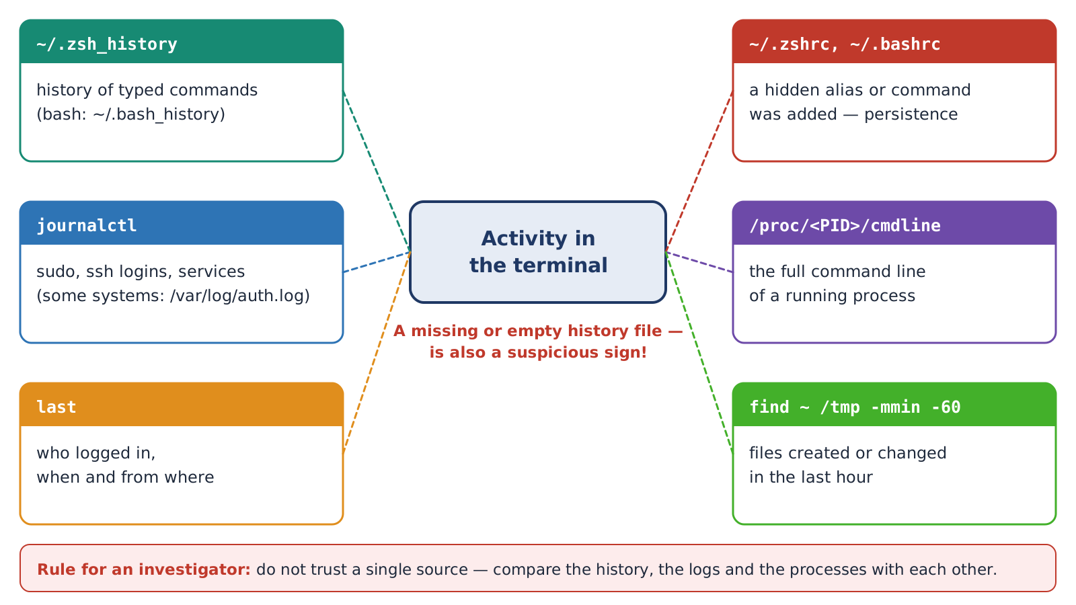
Figure 21. The main sources in which terminal activity is reflected
Table 32. Sources and the commands to view them
Source | What is stored | Viewing
~/.zsh_history, ~/.bash_history | The commands typed by the user | tail ~/.zsh_history
~/.zshrc, ~/.bashrc | Settings executed in every terminal | ls -l ~/.zshrc, tail ~/.zshrc
The systemd journal | Services, the use of sudo, logins to the system | journalctl -n 50, journalctl _COMM=sudo
/proc/PID/ | The command line and directory of a running process | cat /proc/$$/cmdline | tr '\0' ' '
The login log | Who logged in, when and from where | last -n 10, who
File time stamps | Recently created/changed files | find ~ -mmin -60 -type f

Rules for an investigator
• Do not rely fully on a single source: the history file may be deleted or incomplete. Compare the history, the logs, the processes and the file times with each other.
• Make as few changes as possible on the system being inspected: write the results to your own external disk or to a separate directory.
• Record every finding with the time – a report file like the one in Task 13 serves this purpose.

3.2. Rules for working safely in the terminal
• Do not run a command you do not understand. Analyse a command taken from the internet first with man and --help. Text copied from a web page may contain invisible characters – paste it into a text editor first.
• `ls` before `rm`. Before deleting, run ls with the same pattern to see what will be deleted. Be especially careful when using rm -rf with a variable: an empty variable may point to an unexpected directory.
• `sudo` only when needed. Do ordinary work as an ordinary user; do not work permanently as root.
• Do not type a password inside a command – it is visible in the history and in the list of processes.
• A copy before an important file. cp file file.bak takes a second but can save hours of work. In a virtual machine – a snapshot.
• Tell `>` and `>>` apart. Never write to a configuration file with > without checking.

3.3. Common mistakes and their solutions
Table 33. Error reference
Message | Probable cause | Solution
command not found | The name is wrong, the program is not installed or is not in PATH | Check the spelling; apt search; echo $PATH
No such file or directory | The path is wrong or you are in another directory | pwd, ls, complete with Tab
Permission denied | Not enough rights | Check the file; if necessary sudo (Lesson 4)
invalid option | There is no such option | command --help
dquote> / quote> | A quote was not closed | Close it or Ctrl + C
The terminal does not respond | The command is waiting for input or Ctrl + S was pressed | Ctrl + D , Ctrl + C or Ctrl + Q
Could not get lock | Another apt is running | Wait, then try again
The output scrolled off the screen | The output is long | | less or | head

3.4. PowerShell (Topic 1) and the Linux terminal: a comparison table
Table 34. The same task – in two systems
Task | Windows PowerShell | Linux (bash/zsh)
Help | Get-Help Get-Process | man ps, ps --help
Where a command is | Get-Command ls | type -a ls
Processes | Get-Process | ps aux, top
Stopping a process | Stop-Process -Id 1234 | kill 1234
Searching in text | Select-String | grep
Sorting / counting | Sort-Object / Measure-Object | sort / wc -l
Writing to a file | Out-File, > | >, tee
Environment variable | $env:PATH | $PATH
Installing a program | winget install | sudo apt install
Services | Get-Service | systemctl
System log | Event Viewer, Get-WinEvent | journalctl
Command history | Get-History | history

REVIEW QUESTIONS
1. What is the difference between a terminal emulator, a console (TTY) and a shell? Which shell is used in Kali?
2. What does each part of the Kali prompt mean? What is the difference between the $ and # signs?
3. What parts does a command consist of? Explain short and long options with an example.
4. What is the difference between single and double quotes? How do you work with a file name that contains a space?
5. In what order does the shell search for a command? What is PATH and how is a directory added to it?
6. Why is cd not a separate program but a builtin of the shell?
7. When are man, --help, help and man -k used? What is the difference between man 1 passwd and man 5 passwd?
8. Where is the command history stored? What do !!, !$ and Ctrl + R do?
9. What are stdin, stdout and stderr? Give their numbers.
10. Explain the difference between >, >>, 2>, &> and 2>/dev/null with examples.
11. Why do cmd 2>&1 > f and cmd > f 2>&1 give different results?
12. Why does sudo echo x > /etc/f not work, and what is the correct way?
13. What is a pipe (|)? Which question does the chain sort | uniq -c | sort -nr answer, and why is sort needed before uniq?
14. What do the -i, -v, -c, -n and -o options of grep do?
15. What is an exit code? What do the codes 0, 1, 2, 127 and 130 mean?
16. What is the difference between the ;, && and || operators? Why is cd directory && rm … safer?
17. What is the difference between an ordinary and an exported variable? How are settings made permanent?
18. What are PID and PPID? What do the letters R, S, T and Z in the STAT column of ps aux mean?
19. What is the difference between SIGTERM and SIGKILL? Why is kill -9 the last resort?
20. How do &, Ctrl + Z , jobs, bg and fg work?
21. What is the difference between apt update and apt upgrade? What is the difference between remove and purge? What is dpkg -S needed for?
22. How do the active/inactive and enabled/disabled states of a service differ? Which commands change them?
23. What is a shebang? What are the two ways to run a script and how do they differ?
24. Where is terminal activity reflected in the system? Why must several sources be compared in an inspection?

APPENDIX A. QUICK REFERENCE
Table 35. The commands of the lesson – on one sheet
Group | Commands
Shell | echo $SHELL, echo $0, tty, bash, exit, clear
Help | man, --help, man -k, whatis, type -a, which, whereis
History | history, !!, !n, !$, Ctrl + R
Redirection | >, >>, 2>, &>, 2>&1, <, << 'EOF', | tee, /dev/null
Filters | grep -i -v -c -n -o -E, sort -n -r -u, uniq -c, cut -d -f, wc -l, tr, head, tail
Logic | ;, &&, ||, $?, true, false
Variables | NAME=value, $NAME, export, unset, env, printenv, $( ), $(( )), alias, source
Processes | ps aux, ps -ef, pstree, top, htop, pgrep, kill, pkill, jobs, fg, bg, &
Packages | sudo apt update, apt search, apt show, sudo apt install, remove, purge, autoremove, dpkg -l -L -S
Services | systemctl status, start, stop, enable, disable, is-active, is-enabled, journalctl -u
Script | #!/bin/bash, chmod +x, ./script.sh, bash script.sh, bash -n, $1, $#

APPENDIX B. GLOSSARY
Table 36. Basic terms
Term | Also called | In brief
terminal emulator | terminal | A text window inside a graphical environment
shell | command interpreter | A program that understands and executes commands
prompt | command prompt | A sign that the shell is waiting for a command
option / flag | switch | Changes how a command works
argument | parameter | The object a command works on (a file, text)
builtin | internal command | A command built into the shell itself
alias | shortcut | A short name given to a long command
environment variable | env variable | A variable inherited by child processes
standard stream | I/O stream | stdin, stdout, stderr
redirection | I/O redirection | Turning a stream to or from a file
pipe / pipeline | conveyor | Passing the output of one command to another
exit code | return code | The number returned when a command finishes
process / PID | process ID | A running program and its number
signal | software interrupt | A message sent to a process
job control | foreground / background | Managing the foreground and background modes
package manager | installer | A system for installing programs and keeping their record
repository | repo | A store of signed packages
daemon / service | background service | A program that runs permanently in the background
unit | systemd unit | An object managed by systemd
shebang | hashbang | The first line of a script, starting with #!

REFERENCES AND SOURCES
1. Nishanov I.I., Khusenov M.J. Cyber Forensics and Ethical Hacking: Textbook. – Tashkent, 2024. – 390 p.
2. Nishanov I.I., Khusenov M.J. Cyber Forensics and Ethical Hacking: Study guide. – Tashkent, 2024. – 268 p.
3. Shotts W. The Linux Command Line. 2nd ed. – San Francisco: No Starch Press, 2019. – 504 p.
4. OccupyTheWeb. Linux Basics for Hackers. – San Francisco: No Starch Press, 2018. – 248 p.
5. GNU Bash Reference Manual. https://www.gnu.org/software/bash/manual/
6. Zsh Manual. https://zsh.sourceforge.io/Doc/
7. systemd manuals. https://www.freedesktop.org/software/systemd/man/
8. Kali Linux official documentation. https://www.kali.org/docs/
9. Linux man pages. https://man7.org/linux/man-pages/
10. OverTheWire: Bandit – practising the terminal through a game. https://overthewire.org/wargames/bandit/

